**Protractor – Jasmine**

**Notes**

**Protractor online doc**

[**https://github.com/angular/protractor/blob/master/docs/toc.md**](https://github.com/angular/protractor/blob/master/docs/toc.md)

[**http://www.protractortest.org/#/api**](http://www.protractortest.org/#/api)

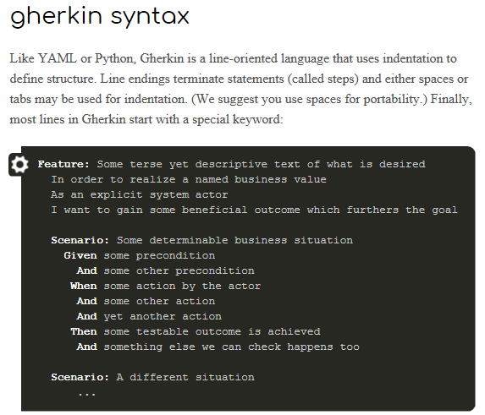

**A sample test:**

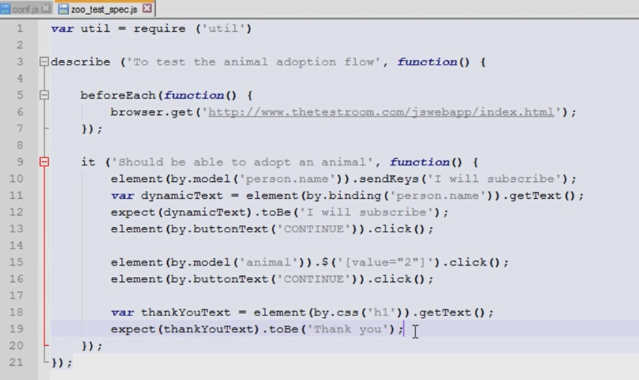

**CSS selector:**

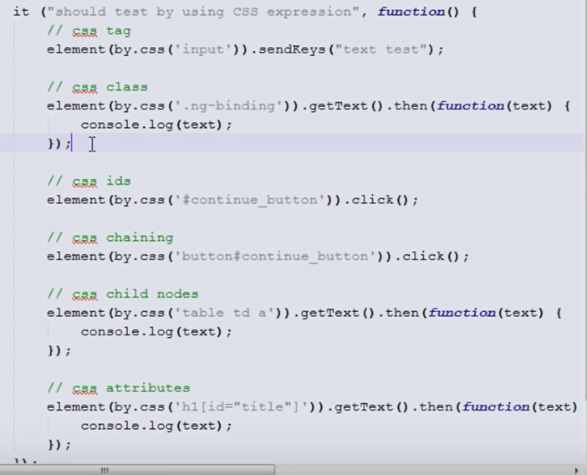

**Pass values into function in page object:**

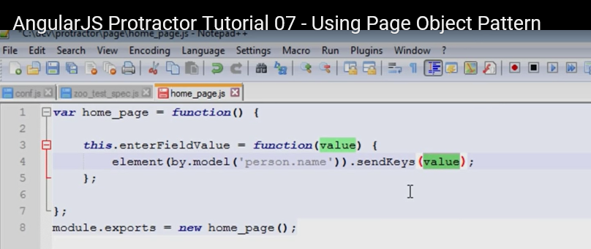

**Return value from function in page object:**

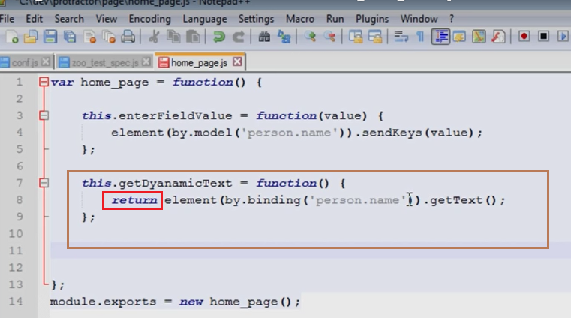

**Use page object in test:**

Note: “xit” makes “it” still a test, but not executed.

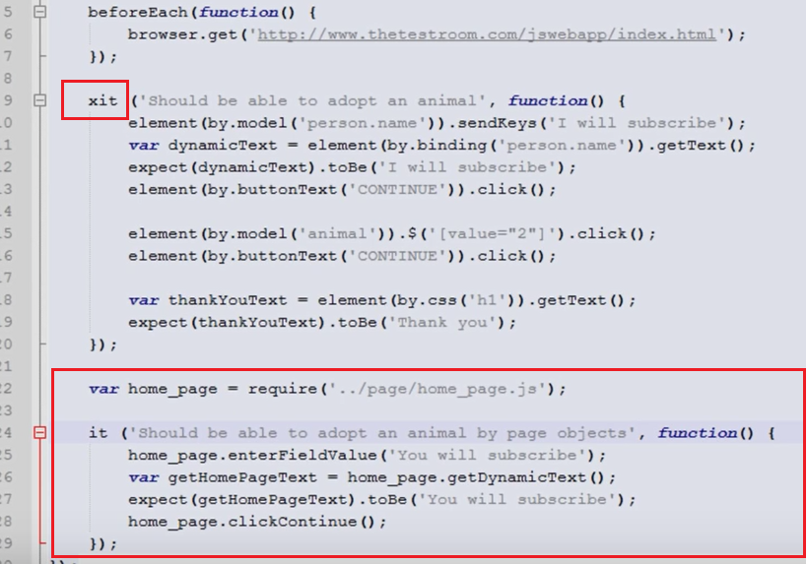

**Pass parameter into function, for object property.**

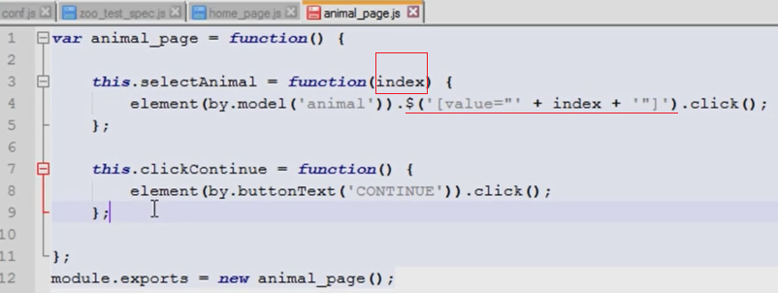

**Return the next page in current page.**

After clicking ‘continue’, it goes to animal_page from home_page.

Note:

“../page/animal_page.js” 🡺 starts from upper folder of page

“./animal_page.js” 🡺 current page

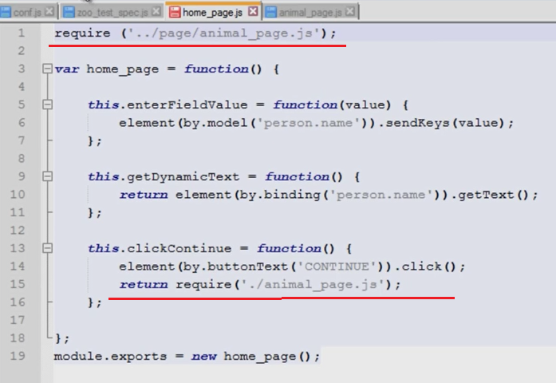

In test script, return the next page from current page, and then do things on next page.

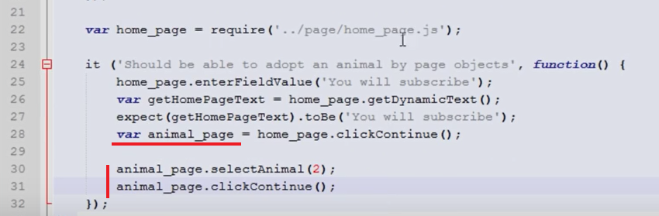

Have parameters in construct the page object.

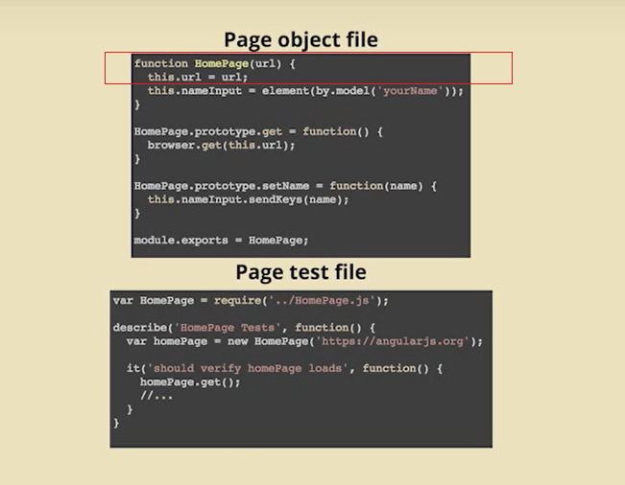

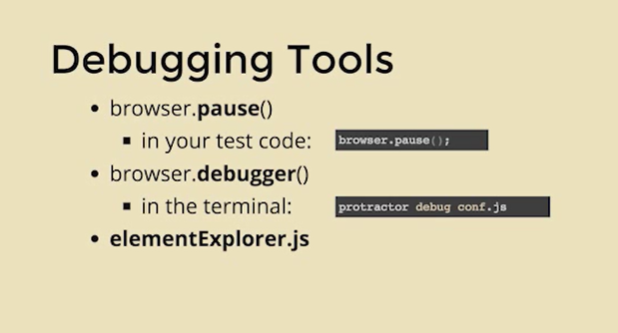

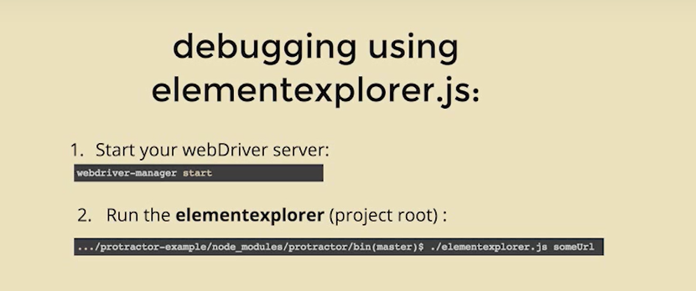

Protractor / Jasmine, sample config.

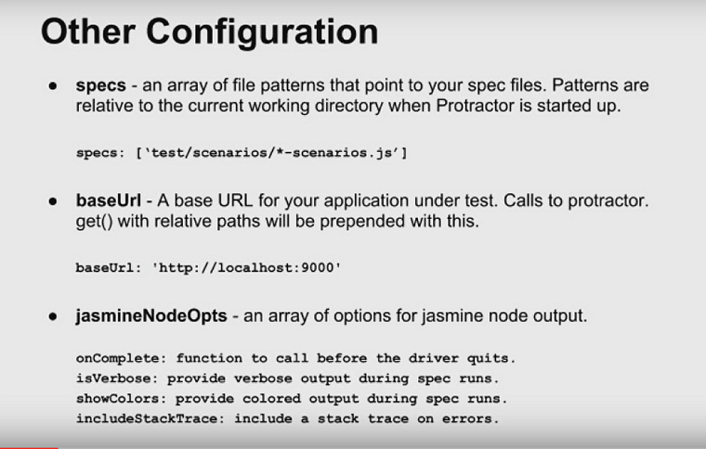

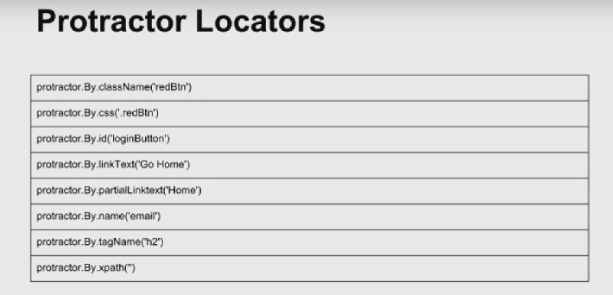

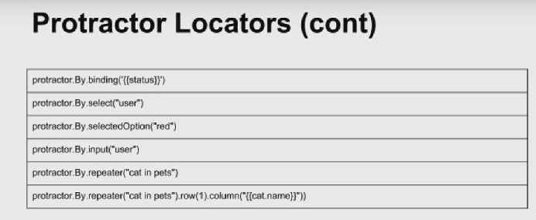

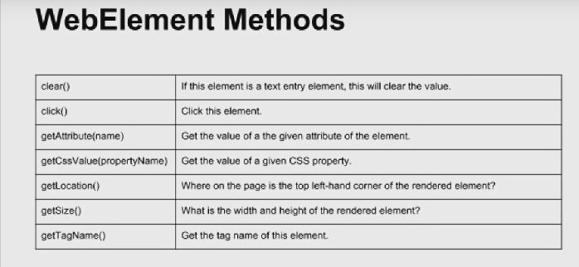

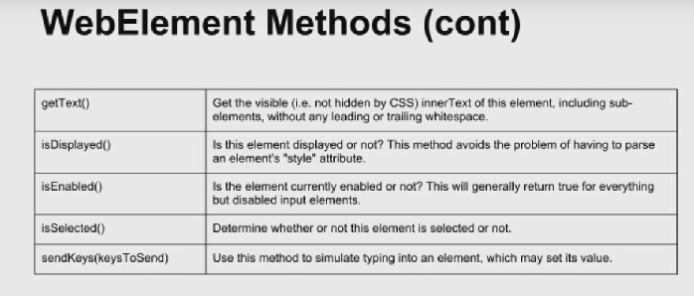

Special character should using \ before it.

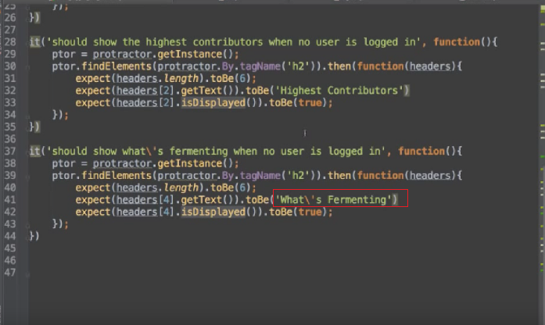

Sauce Lab configuration:

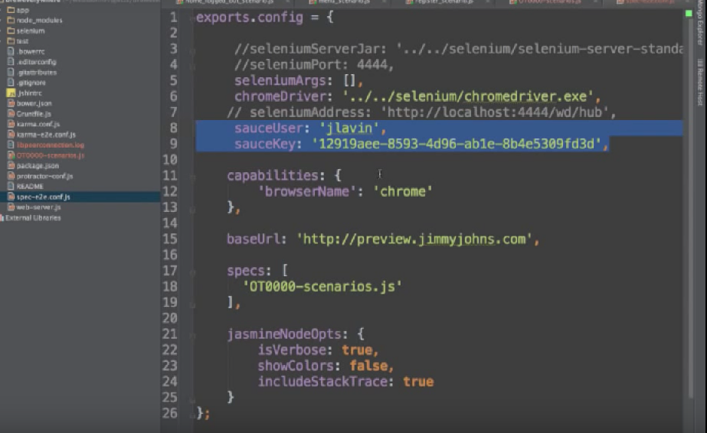

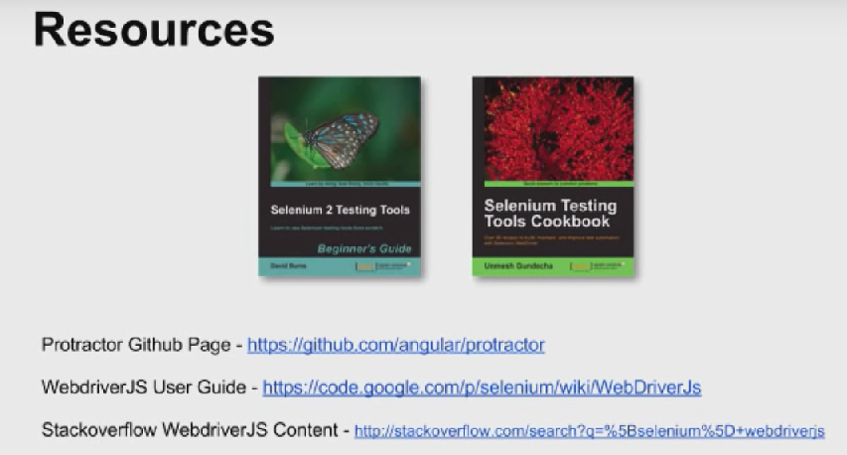

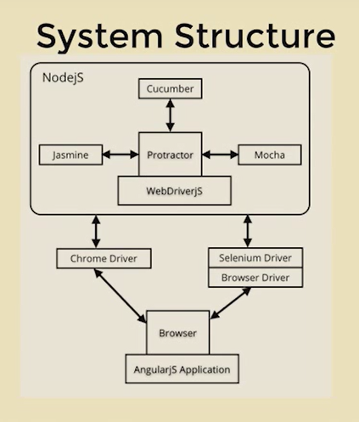

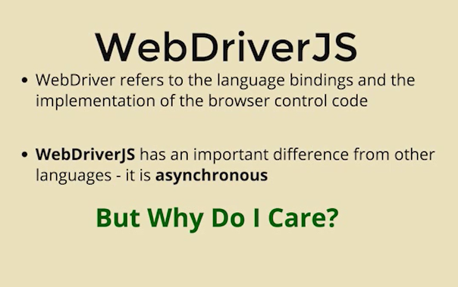

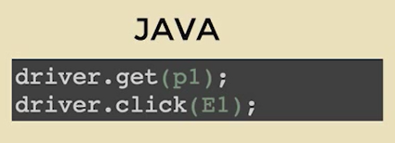

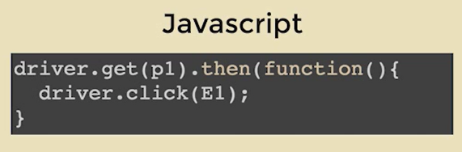

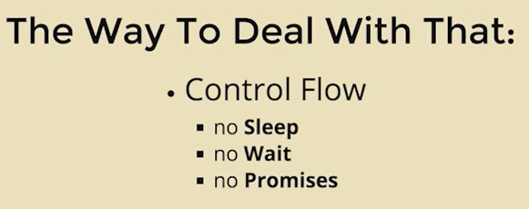

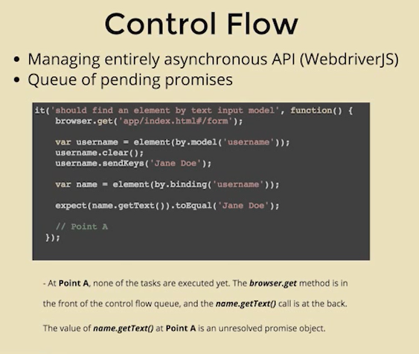

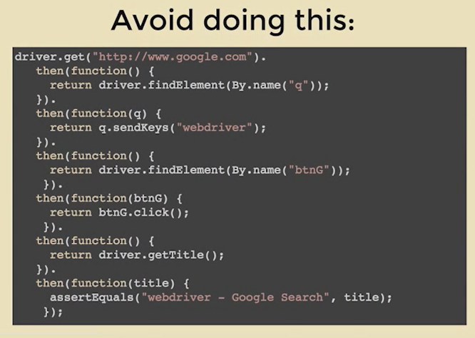

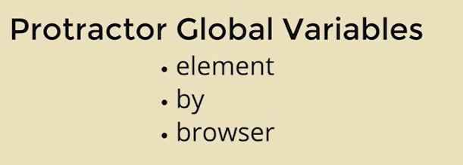

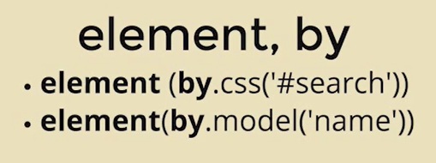

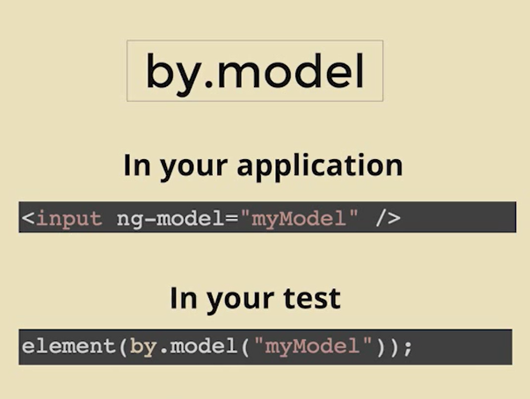

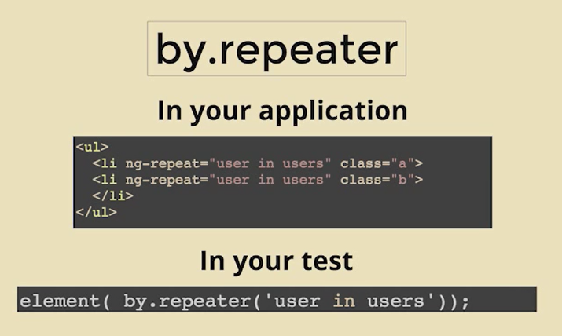

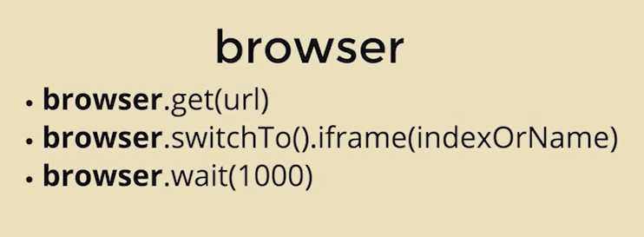

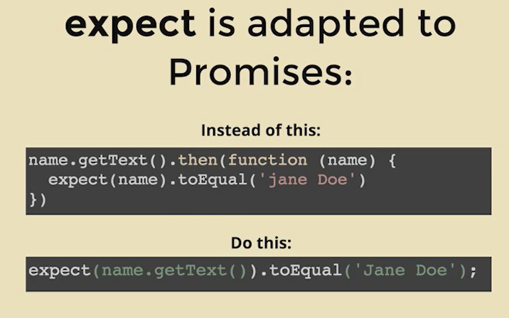

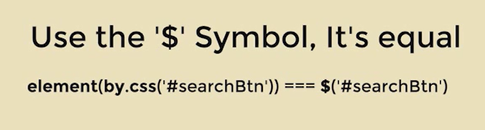

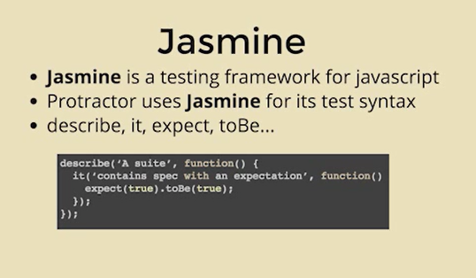

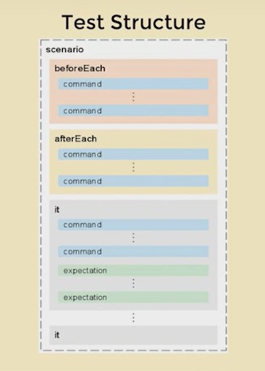

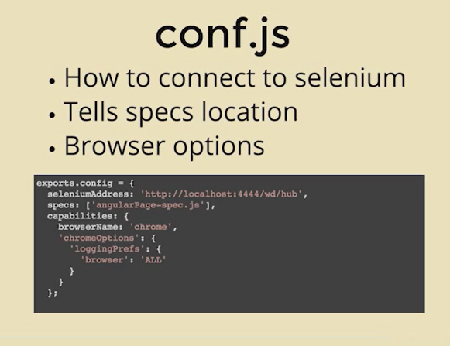

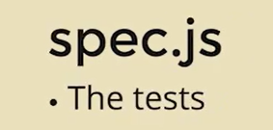

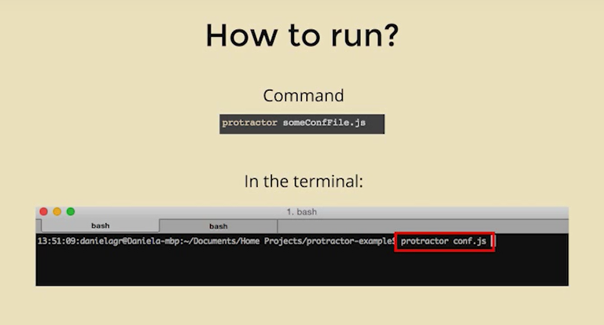

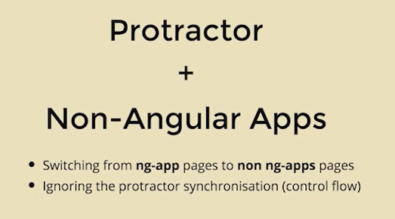

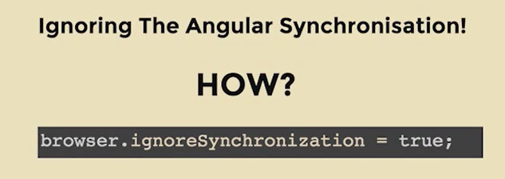

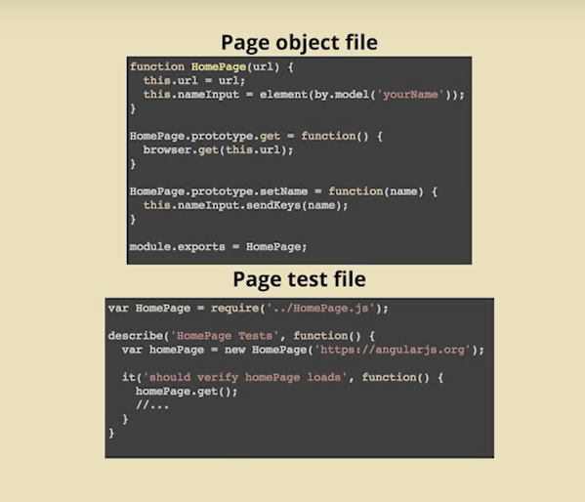

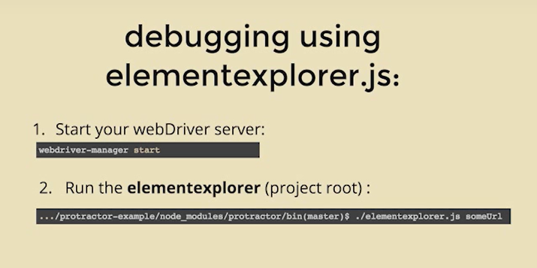



“use strict”;

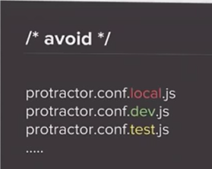

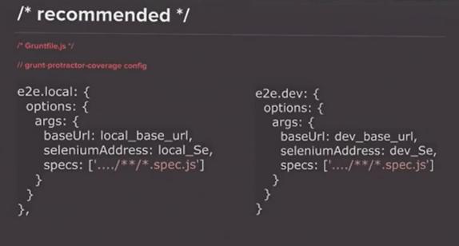

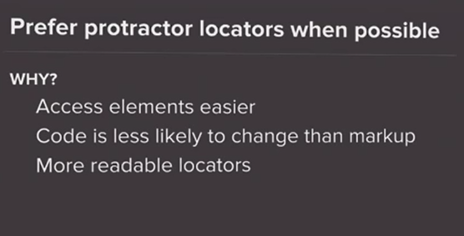

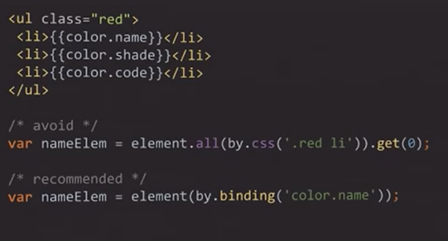

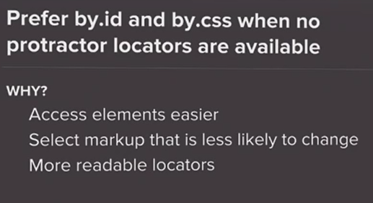

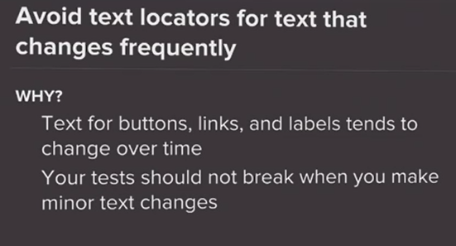

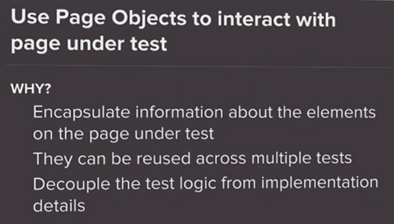

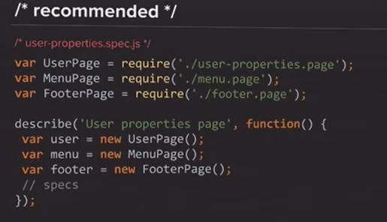

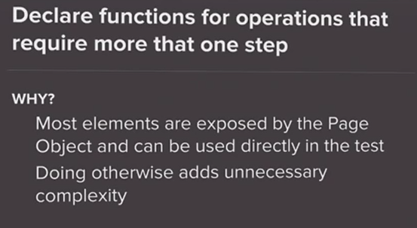

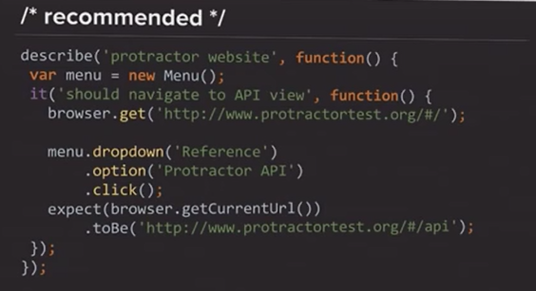

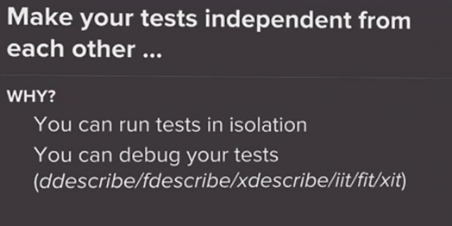

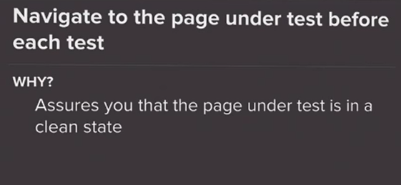

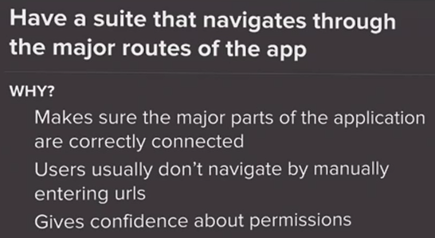

Folder structure:

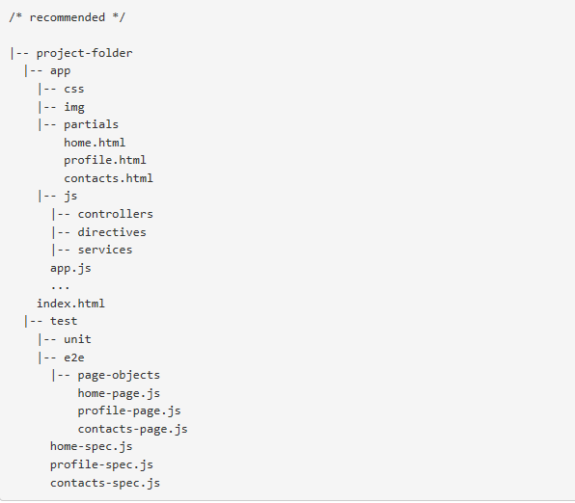

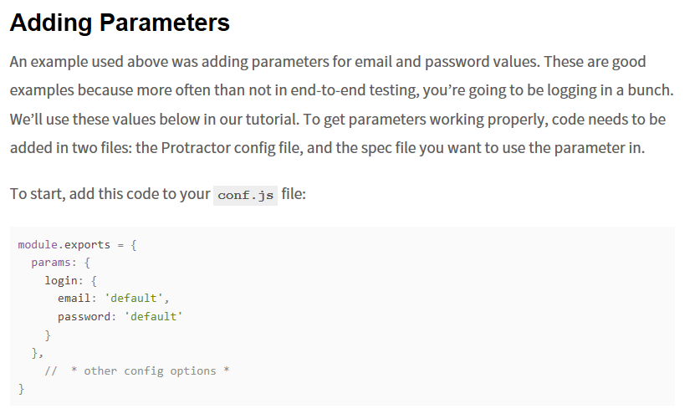

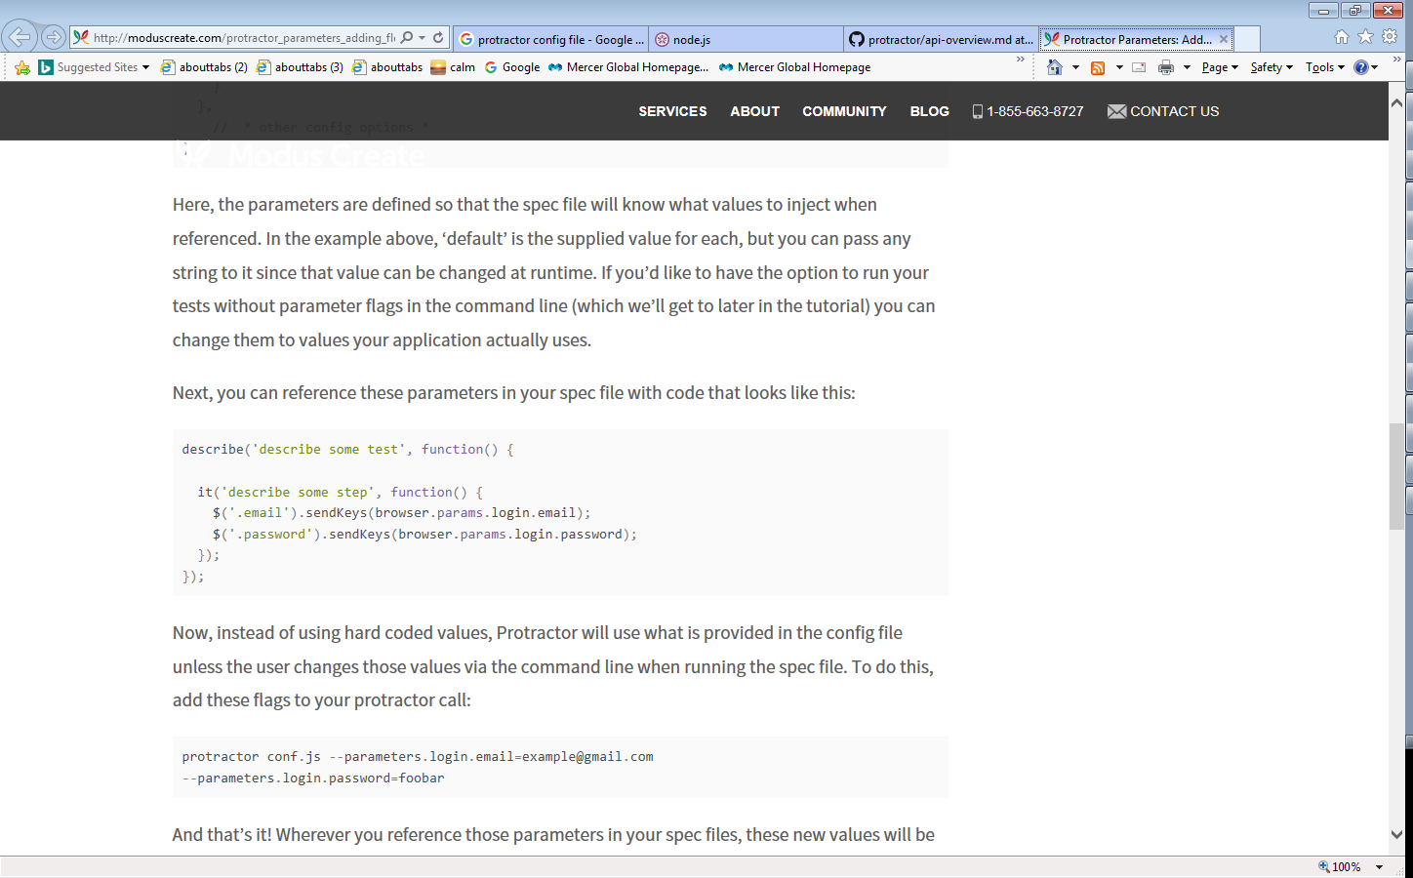

Do not use **var**, instead use **const** (for constants) or **let** (for variables) - this helps code quality.

Refer to <https://stackoverflow.com/questions/762011/whats-the-difference-between-using-let-and-var-to-declare-a-variable>

Refer to <https://developer.mozilla.org/en/docs/Web/JavaScript/Reference/Statements/let>

npm install --save-dev shelljs

used to call external exe, bat, etc…..

<https://www.npmjs.com/package/shelljs>

Pick up one element, wait for it visible to judge if page is ready.

**let** ec = **protractor**.**ExpectedConditions**;

**browser**.**driver**.wait(ec.visibilityOf(**this**.**_Submit**), **browser**.**params**.**timeouts**.**page_timeout**, **'Element in page takes too long to appear in the DOM'**);

Send keys and keyboard into the element:

**this**.**_Client**.sendKeys(client + **protractor**.**Key**.ENTER);

note: ‘ENTER’ shows unresolved variable (same as BACK_SPACE), but it works fine.

below link should be the prefer way:

<https://www.linkedin.com/pulse/checkboxes-protractor-meir-shahar>

**this**.__setCheckBoxTo = **function**(tureOrfalse){  
 **let** chk = **element**(**by**.id(**'ctl00_FSMMasterContentPlaceholder_planSelectionUserControl_ClientProjectPlanSelector__grid_PlanSelector_ctl00_ctl04_SelectColumnSelectCheckBox'**));  
 chk.isSelected().then(**function**(selected) {  
 **if** (selected !== tureOrfalse) {  
 chk.click();  
 }  
 }  
 )  
};

use expect to check value

expect(element.isSelected()).toBe(true);

table

*Important Note:*

*element.count() will not directly give you the count. It will return you a promise which needs to be resolved explicitly. Look at below example*.

*So, have to use .then function, because it returns promise*

*// find all tables***element**.all(**by**.**css**(**'table'**)).count().then(**function**(rowCount){  
 ***console***.log(**"table Count:"**+rowCount)  
})  
  
*// find the row number of first table***element**.all(**by**.**css**(**'table'**)).first().all(**by**.**css**(**'tr'**)).count().then(**function**(rowCount){  
 ***console***.log(**"table 1, row:"**+rowCount)  
  
});  
  
*// find the row number of other tables***for**(**let** i=1;i<9;i++)  
{  
 **element**.all(**by**.**css**(**'table'**)).get(i).all(**by**.**css**(**'tr'**)).count().then(**function**(rowCount){  
 ***console***.log(i + **"table, row:"**+rowCount)  
 })  
}  
  
*// find the row number for the table given the id***element**(**by**.id(**'ctl00_FSMMasterContentPlaceholder_planSelectionUserControl_ClientProjectPlanSelectorgrid_PlanSelector_ctl00'**)).all(**by**.**tagName**(**'tr'**)).count().then(**function**(rowCount){  
 ***console***.log(**"my table, row:"**+rowCount)  
});

Search table data and click

<http://www.protractortest.org/#/api?view=ElementArrayFinder.prototype.filter>

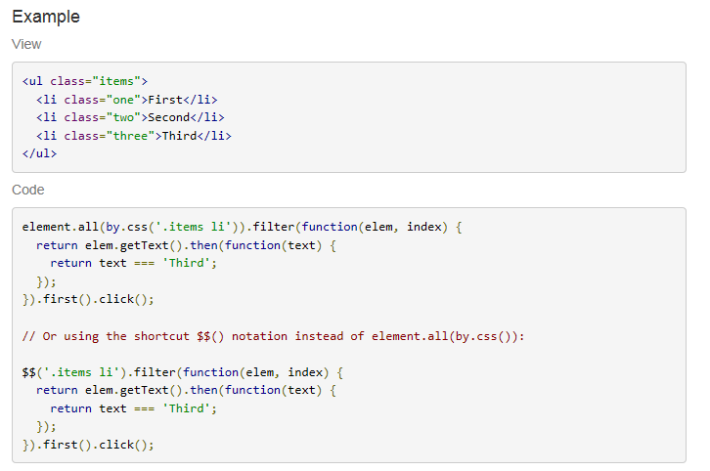

Hash table

Typically, you would use a hash table for a situation where you want to map a name to some value, and be able to retrieve both.

var obj = { myFirstName: 'John' };

obj.foo = 'Another name';

for(key in obj)

console.info(key + ': ' + obj[key]);

How to return element text:

**let** tmp = pplan_selection.**_Client**.getAttribute(**'value'**).then(**function**(text){  
 ***console***.log(**'value inside'** + text);  
 **return** text;  
});  
tmp.then(**function**(text){  
 ***console***.log(**'value outside'** + text);  
});

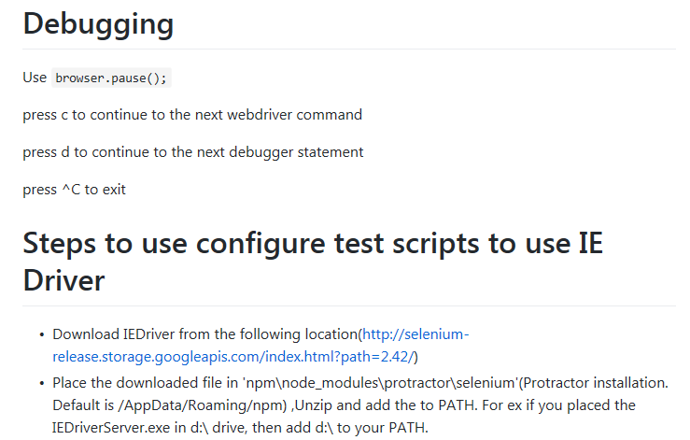

Find the path in Environment Variables, and copy the ie driver to it.

Set the browserName to ‘internet explorer’ in conf.js

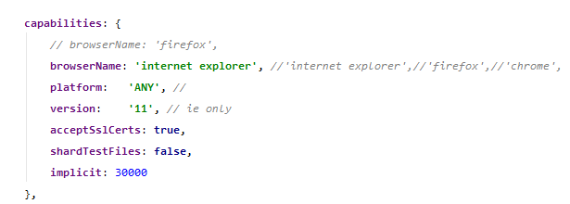

CheckBox

First of all, check if this is the only element matching the selector and you are actually locating the desired checkbox. Also, try moving to the element and then making a click:

var checkbox = $('.checkbox-class-name');

browser.actions().mouseMove(checkbox).click().perform();

Or, scroll into element's view:

browser.executeScript("arguments[0].scrollIntoView();", checkbox.getWebElement());

checkbox.click();

Or, click via JavaScript (do understand the [implications](https://stackoverflow.com/questions/34562061/webdriver-click-vs-javascript-click) though):

browser.executeScript("arguments[0].click();", checkbox.getWebElement());

Use javascript to click on element (edge issue workaround)

WebElement element = driver.findElement(By.id("gbqfd"));

JavascriptExecutor executor = (JavascriptExecutor)driver;

executor.executeScript("arguments[0].click();", element);

driver.execute_script("document.getElementById('q').value='value here'")

protractor send keys

var enter = browser.actions().sendKeys(protractor.Key.ENTER);

enter.perform();

You can use activeElement() feature of selenium to access the currently focused element [source](https://stackoverflow.com/a/7492253/1048479).

E.g.

// select the current page context's active element

browser.switchTo().activeElement().sendKeys('Test')

{![webdriver.promise.Promise](http://appfigures.github.io/webdriver-js-api-reference/symbols/webdriver.promise.Promise.html)} **sendKeys**(var_args)

Schedules a command to type a sequence on the DOM element represented by this instance.

Modifier keys (SHIFT, CONTROL, ALT, META) are stateful; once a modifier is processed in the keysequence, that key state is toggled until one of the following occurs:

* The modifier key is encountered again in the sequence. At this point the state of the key is toggled (along with the appropriate keyup/down events).
* The {@code webdriver.Key.NULL} key is encountered in the sequence. When this key is encountered, all modifier keys current in the down state are released (with accompanying keyup events). The NULL key can be used to simulate common keyboard shortcuts:
* element.sendKeys("text was",
* webdriver.Key.CONTROL, "a", webdriver.Key.NULL,
* "now text is");
* // Alternatively:
* element.sendKeys("text was",
* webdriver.Key.chord(webdriver.Key.CONTROL, "a"),
* "now text is");
* The end of the keysequence is encountered. When there are no more keys to type, all depressed modifier keys are released (with accompanying keyup events).

**Note:** On browsers where native keyboard events are not yet supported (e.g. Firefox on OS X), key events will be synthesized. Special punctionation keys will be synthesized according to a standard QWERTY en-us keyboard layout.

**Parameters:**

{...string} **var_args**

The sequence of keys to type. All arguments will be joined into a single sequence (var_args is permitted for convenience).

**Returns:**

{!*[webdriver.promise.Promise](http://appfigures.github.io/webdriver-js-api-reference/symbols/webdriver.promise.Promise.html)*} A promise that will be resolved when all keys have been typed.

Wait for element invisible

There is a built-in [invisibilityOf](http://www.protractortest.org/#/api?view=ProtractorExpectedConditions.prototype.invisibilityOf) Expected Condition specifically for this use case:

page.sortByBalanceSelector.click();

var loader = element(by.id("loader"));

var EC = protractor.ExpectedConditions;

browser.wait(EC.invisibilityOf(loader), 5000);

Data driven

<http://www.ontestautomation.com/data-driven-javascript-tests-using-jasmine/>

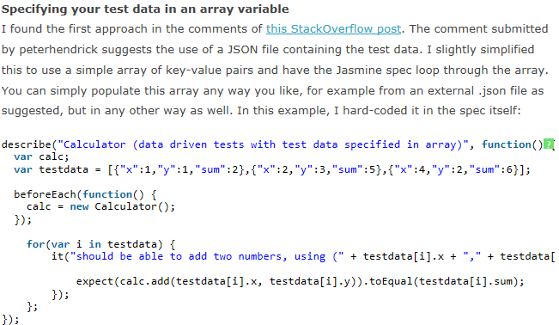

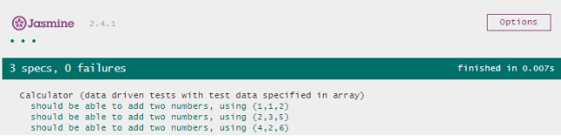

External jason file as input data

<https://groups.google.com/forum/#!topic/angular/szvTofhwp1M>

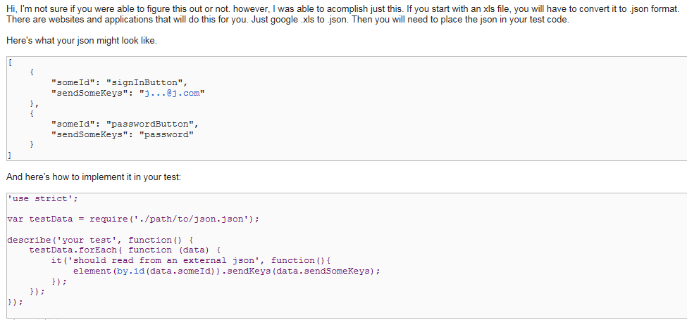

Loop multiple it functions

<https://github.com/angular/protractor/issues/620>

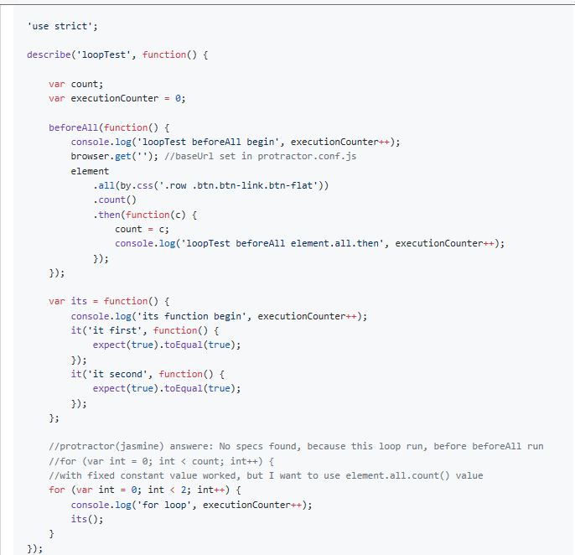

Jasmine data provider

<https://www.npmjs.com/package/jasmine-data-provider>

npm install jasmine-data-provider

var using = require('jasmine-data-provider');

describe('test subtraction with data provider - direct array', function () {

    using([{a: 5, b: 2, expected: 3}, {a: 25, b: 26, expected: -1}], function (data) {

        it('should calc with operator -', function () {

            var result = calculator.calc(data.a, data.b, '-');

            expect(result).toEqual(data.expected);

        });

    });

});

Using function as a data provider

describe('test addition with data provider - provider function', function () {

    function plusProvider() {

        return [

            {a: 2, b: 3, expected: 5},

            {a: '14', b: 15, expected: 29},

            {a: 12, b: '13', expected: 25},

            {a: '22', b: '13', expected: 35},

        ];

    }

     using(plusProvider, function (data) {

        it('should calc with operator +', function () {

            var result = calculator.calc(data.a, data.b, '+');

             expect(result).toEqual(data.expected);

        });

    });

});

Now you can use object with a description that is passed into to the callback function as the last parameter

describe('My fantastic test', function () {

    var objectDataProvider = {

        'First one is awesome!': {a: 6, b: 3, expected: 9},

        'Second test should fail': {a: 8, b: 1, expected: 10}

    };

    using(objectDataProvider, function (data, description) {

        it(description, function () {

            var result = calculator.calc(data.a, data.b, '+');

            expect(result).toEqual(data.expected);

        });

    });

});

Ways to run on multiple browsers with different specs for each

<https://stackoverflow.com/questions/27872783/how-do-i-open-multiple-windows-or-operate-multiple-instances/27874090#27874090>

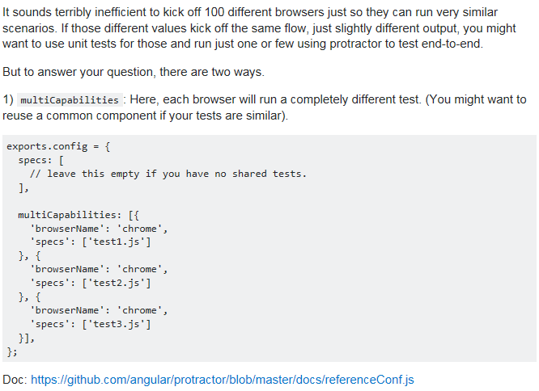

Run one test on multiple browsers.

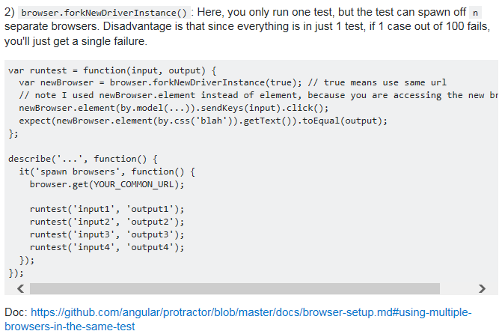

Read/write Excel using ‘xlsx’ package

<https://www.npmjs.com/package/xlsx#parsing-workbooks>

Timer for performance

<https://stackoverflow.com/questions/37955782/is-there-a-way-to-add-timer-events-to-protractors-control-flow-to-measure-execu>

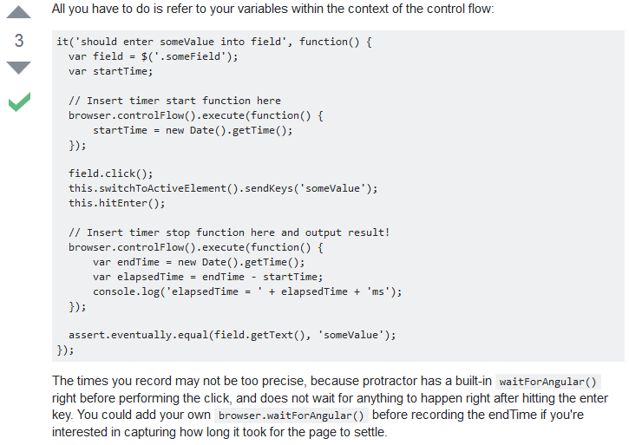

CSS start with syntax: [*attribute*^=*value*]

CSS contains syntax: [*attribute*\*=*value*]

CSS end syntax: [*attribute*$=*value*]

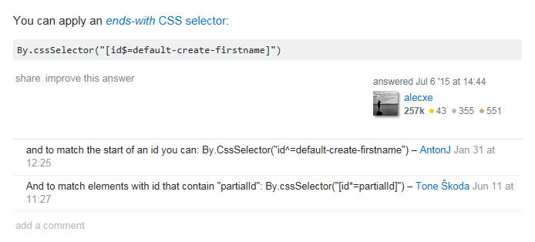

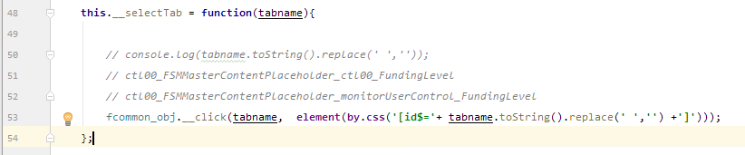

[protractor-helpers](https://www.npmjs.com/package/protractor-helpers)

Bottom of Form

<https://www.npmjs.com/package/protractor-helpers>

## Throwing Errors

Sometimes you need to purposefully throw errors (for instance where a value lands on the default branch of a switch statement). To do this simply use e.g:

**throw new** Error(**'Does not support planDesign === '** + planDesign);

and the Jasmine report will show the full stack trace so you know where and why the code failed.

## Code Examples for Checking Elements

| **used for** | **code** |
| --- | --- |
| Check existence of element (can be shown or hidden). | expect(**icon**.isPresent()).toBe(**true**); |
| Check element is shown. | expect(**icon**.isDisplayed()).toBe(**true**); |
| Check text in element is equal to expected value. | expect(**copyrightValue**.getText()).toEqual(d.getFullYear()); |
| Check URL contains expected value. | expect(**browser**.getCurrentUrl()).toContain(**ov3RootUrl**); |
| Check URL contains expected value. This uses regular expressions (RegEx for short). | expect(**browser**.getCurrentUrl()).toMatch(**ov3RootUrl**); |
| Get link value within element. | expect(article.getAttribute(**'href'**)).toBe(cta); |
| Check element contains alphanumeric text.  For OV3 this code is wrapped in a common function which uses a constant for the RegEx - see function example.  Note that RegEx is defined as a regular expression object ***not*** a string object e.g.  /OVT$/  ***not***  'OVT$' | expect(el.getText()).toMatch(/[A-Za-z0-9 _.,!"'/$]*/);  Example using **common-tests.js** function:  **this**.isPensionerPlanDescriptionShown = **function** (page) {  commonTests.isElementDisplayedContainingText(page.**pensionerCard**.**typeLabel**); } |
| ***Conditionally*** check whether element displayed or not.  Note isDisplayed() cannot be used within conditional logic flow such as if … then … else statements.  For OV3 this code is ***not*** currently wrapped in a function as it seems impossible for promises to be resolved correctly in a common function.  For a full example please see '**Error! Reference source not found.**' | **let** ec = **protractor**.**ExpectedConditions**; ec.visibilityOf(el).call().then(**function**(visible) {  **if** (visible) {  **return true**;  } **else** {  **return false**;  } }); |

Using CSS selector

<http://luxiyalu.com/protractor-locators-selectors/>

$('#some-id') // element(by.id())

$('.some-class') // element(by.className())

$('tag-name') // element(by.tagName())

$('[ng-message=required]') // remember to leave out the double quotes around the value of attribute

$('#parent #child') // select one child inside parent

$('ul li') // select all children inside parent

$('ul li').first() // select first of children

$('ul li').last() // select last of children

$('ul li').get(index) // select index-th of child

element(by.model('data'));

element(by.repeater('cat in pets'));

element(by.options('c for c in colors'))

element(by.binding('value')); // only look through the elements with ng-binding attribute

element(by.buttonText('Save')); // the whole of button text

element(by.partialButtonText('Save')); // part of button text

element(by.cssContainingText('.pet', 'Dog')) // for selecting this: <li class="pet">Dog</li>

element(by.deepCss('span')) // for selecting all level of spans <span><span>x</span></span>

right-click and select item:

<https://stackoverflow.com/questions/33929577/protractor-how-to-select-an-item-from-list-when-right-clicked>

protractor locators

<http://www.protractortest.org/#/locators>

get element location:

element.getLocation().then(**function** (location) {  
 expect(location.**x**).toEqual(100);  
 expect(location.**y**).toEqual(100);  
});

click x, y position of an element:

browser.actions().mouseMove(element, {**x**: 30, **y**:10}).click(**protractor**.**Button**.RIGHT).perform();

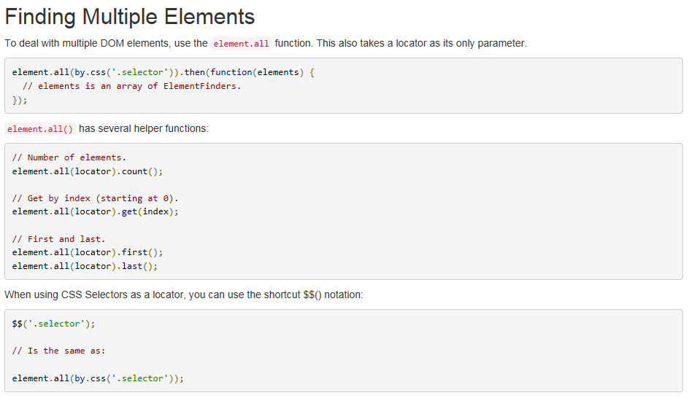

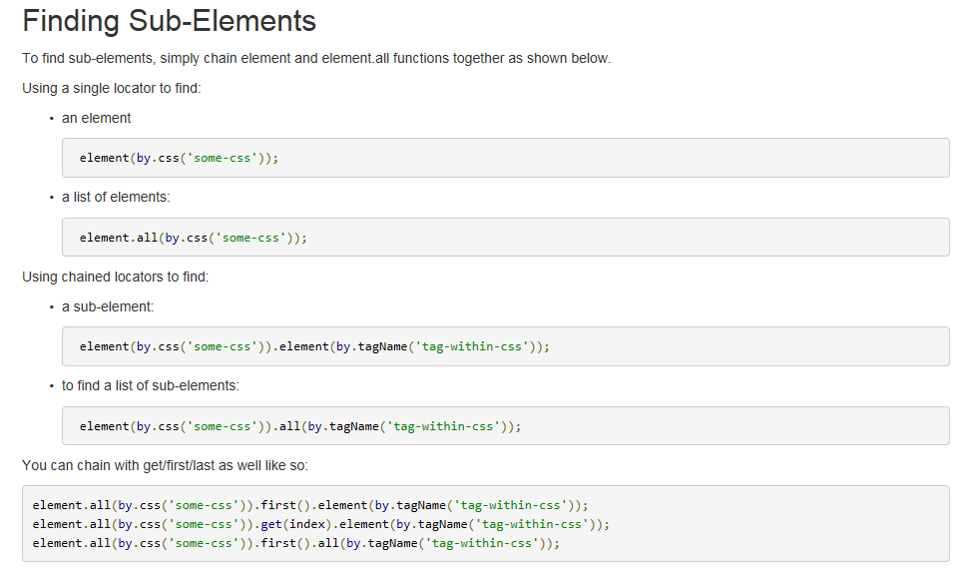

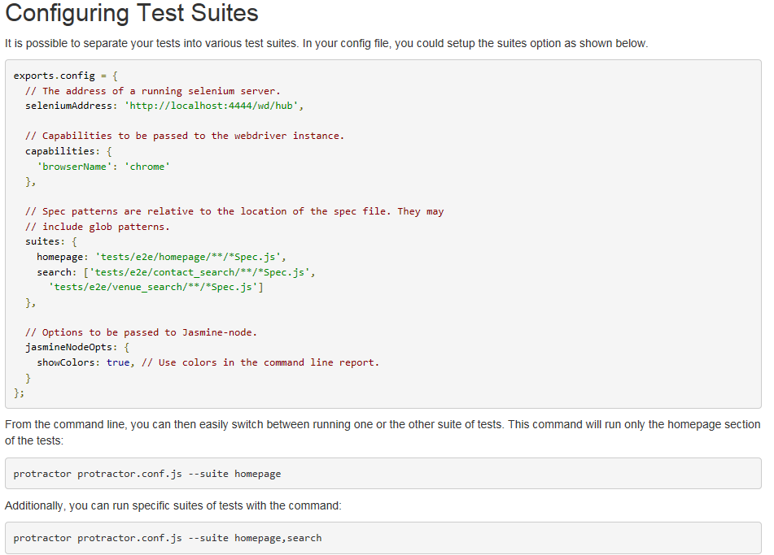

Expect usage:

expect(text).toContain("ArrowGrey Slim Fit Formal Trouser");

expect(text).toMatch("ArrowGrey Slim Fit Formal Trouser");

expect(text).toStartWith("ArrowGrey Slim Fit Formal Trouser");

protractor sync/promise

Protractor actually runs asynchronously, but it takes care to synchronize the test steps with your application, so that they will be executed properly, and the right time, only when the application is ready and has processed the previous step. All the actions (mouse clicks, keyboard typing, etc.) and all the checks / expectations actually return promises, that will be executed some time in the future. At the start of your tests, all of your test scripts are parsed and a chain of promises is created. After that, they begin to execute one after another - protractor takes care for that. It also takes care to synchronize your test steps (actions, expectations, etc.) with angular in your application under test. So after each step (promise), it automatically calls waitForAngular - no need to do that yourself. This way, you can write the steps in a synchronous matter, but they will be executed asynchronously, at the right time. However, this is not entirely true - protractor is a wrapper over webdriverjs - so all protractor methods are automatically synced, but you are also able to call webdriver methods directly and they will not be synced. You can check which are the protractor and which are the webdriverjs methods available in the documentation here - [**http://www.protractortest.org/#/api**](http://www.protractortest.org/#/api)

Hope, I was able to explain this in a more understandable way.

Return value form object

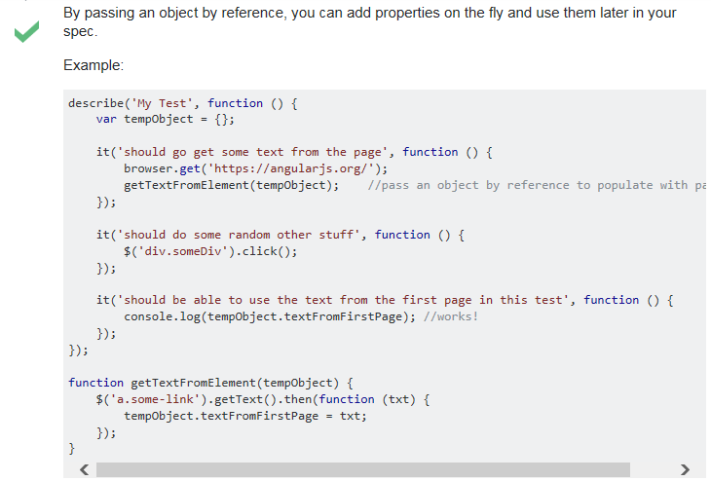

Radio button status:

cols[iCol].**element**(**by**.**css**(**'[type=radio]'**)).isSelected().then(**function**(selected){  
 ***console***.log(**'radio status:'** + selected);  
})

expect(expected).toBe(cols[iCol].**element**(**by**.**css**(**'[type=radio]'**)).isSelected());

check element enable/disable

expect(cols[iCol].**element**(**by**.**css**(**'[type=radio]'**)).isEnabled()).toBe(expected);  
expect(cols[iCol].**element**(**by**.**css**(**'[type=radio]'**)).getAttribute(**'disabled'**)).toBe(expected);

get selected item in dropdown:

not default, after selection, can return selected using below code

**this**.**_SelectApplication**.**element**(**by**.**css**(**'option:checked'**)).getText().then(**function**(txt){  
 expect(txt).toMatch(expected);  
});

default, need to click on the dropdown and get the first one:

fcommon_obj.__click(**'_SelectApplication'**, **this**.**_SelectApplication**);  
**this**.**_SelectApplication**.all(**by**.**tagName**(**'option'**)).get(0).getText().then(**function**(txt){  
 expect(txt).toMatch(expected);  
});

compare string

**let** a= **'abc'**;  
**let** b=**'abd'**

expect(a).toBeGreaterThan(b);  
expect(b).toBeLessThan(a);

expect(a).not.toBeGreaterThan(b);

expect(b).not.toBeLessThan(a);

autoIT file open:

 WinWait("Choose File to Upload")

 $hChoose = WinGetHandle("Choose File to Upload")

 ControlSetText($hChoose, "", "Edit1", "C:\UsersSLyFoxDesktoptest.jpg")

 ControlClick($hChoose, "", "Button1")

 $oIE.document.forms(0).submit() ;This is the "Finish uploading pictures" button

|  |  |
| --- | --- |
|  | <https://stackoverflow.com/questions/29928856/protractor-failed-stale-element-reference-element-is-not-attached-to-the-pag>  loop multi-selection  How about using [each(element, index)](http://angular.github.io/protractor/#/api?view=ElementArrayFinder.prototype.each):  element.all(by.className('multiSelectLi')).each(function(option, index) {  if (index < limit) {  option.click();  }  });  Or, in conjunction with [filter(element, index)](http://angular.github.io/protractor/#/api?view=ElementArrayFinder.prototype.filter):  element.all(by.className('multiSelectLi')).filter(function(option, index) {  return index < limit;  }).each(function(option) {  option.click();  });  Also, a naive approach to solve the problem (calling element.all() continuously in the loop):  for (var index = 0; index < limit; index++) {  var option = element.all(by.className('multiSelectLi')).get(index);  option.click();  }; |

Webdriverjs-retry

<https://github.com/juliemr/webdriverjs-retry>

catch error:

loader.isDisplayed().then(**function**(displayed){  
 **if**(displayed){  
 ***console***.log(**'..... iLoadingAppear.....: '** + ++iLoadingAppear);  
 }  
}, **function**(err){  
 ***console***.log(**'Error: Stale element reference'**);  
});

BeforeAll, AfterAll, BeforeEach, AfterEach

<https://github.com/nonplus/jasmine-beforeAll>

get dropdown selected option

padequacy_setup_retirement.**_RTA_ProrateTarget**.getAttribute(**'value'**).then(**function**(txt){  
 *expect*(txt).toBe(**'False'**);  
});

verify text exists

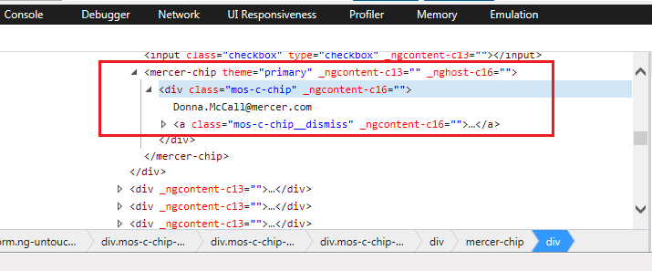

**element**(**by**.cssContainingText(**'.mos-c-chip'**, **'Donna.McCall@mercer.com**))

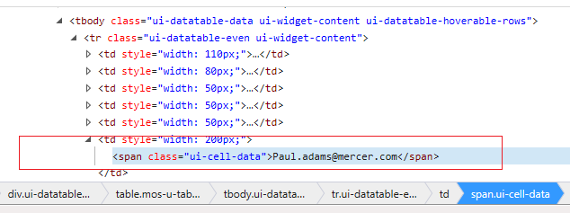

**element**(**by**.cssContainingText(**'.ui-cell-data'**, **'Paul.adams@mercer.com'**))

xPath

<https://sqa.stackexchange.com/questions/10342/how-to-find-element-using-contains-in-xpath>

split string

**let** ss = **'1-September-2017'**;  
***console***.log(ss.split(**'-'**)[0]);  
***console***.log(ss.split(**'-'**)[1]);  
***console***.log(ss.split(**'-'**)[2]);

check Tab is selected (Xpath get parent)

<https://stackoverflow.com/questions/37129531/how-can-i-write-a-protractor-test-for-a-listed-tab-element-where-it-checks-if-it>

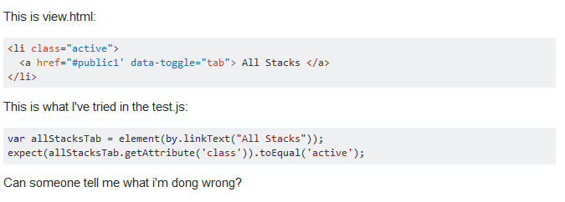

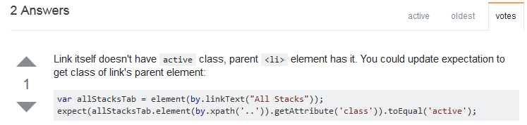

Using XPath to get element’s parent, it works fine in UAR:

element(by.linkText("Dashboard")).**element(by.xpath(".."));**

[**https://www.w3schools.com/jsref/jsref_number.asp**](https://www.w3schools.com/jsref/jsref_number.asp)

java script reference, very useful.

**Javascript Code for Line Break Removal**

Here's where the javascript magic happens:

//We define the text variable that needs to be cleansed of line breaks.  
Var someText = "Here's some text.\n It has some line breaks that will be removed \r using Javascript.\r\n";   
  
//This javascript code removes all 3 types of line breaks  
someText = someText.replace(/(\r\n|\n|\r)/gm,"");

webber = webber.replace("\r\n","");

<https://www.textfixer.com/tutorials/javascript-line-breaks.php>

Get element background color:

plogin.**_SSOLogin**.getCssValue(**'background-color'**).then(**function**(buttonColor) {  
 expect(buttonColor).toBe(testData.**color_SSOLoginBtn**);  
});

Get element text color:

plogin.**_SSOLogin**.getCssValue(**'color'**).then(**function**(textColor) {  
 expect(textColor).toBe(testData.**color_SSOLoginTxt**);  
});

Get element location:

plogin.**_SSOLogin**.getLocation().then(**function** (location) {  
 expect(location.**x**).toBe(testData.**xPos_SSOLoginBtn**);  
 expect(location.**y**).toBe(testData.**yPos_SSOLoginBtn**);  
});

**debug test**

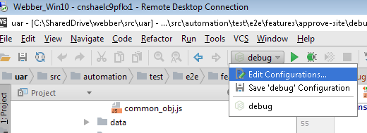

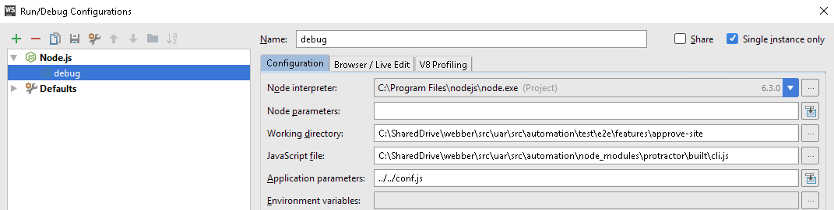

In conf.js, set the specs to the test script want to debug, for example, debug1.js here.

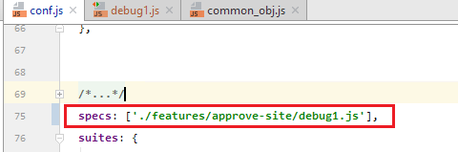

**Run tests on multiple browsers:**

You can use the maxSessionsvar inside protractor configuration conf.js

// Maximum number of total browser sessions to run. Tests are queued in

// sequence if number of browser sessions is limited by this parameter.

// Use a number less than 1 to denote unlimited. Default is unlimited.

maxSessions: -1

More info <https://github.com/angular/protractor/blob/master/docs/referenceConf.js#L198>

Example conf.js (firefox, safari, chrome, chrome device simulators):

multiCapabilities: [

{

browserName: 'firefox'

},

{

browserName: 'safari'

},

{

browserName: 'chrome'

},

{

browserName: 'chrome',

// List of devices https://cs.chromium.org/chromium/src/chrome/test/chromedriver/chrome/mobile_device_list.cc

'deviceName': 'Google Nexus 5'

},

{

browserName: 'chrome',

'deviceName': 'Apple iPhone 6'

},

{

browserName: 'chrome',

'deviceName': 'Apple iPad'

},

{

browserName: 'chrome',

'deviceName': 'Samsung Galaxy S4'

}

],

maxSessions: 1

More examples and testing in real devices <https://github.com/aluzardo/protractor-cucumber-tests>

**Add Path**

If encounter error like below:

*Protractor/webdriver-manager is not recognized as internal or external command…...*

Step 1: Add **%USERPROFILE%\AppData\Roaming\npm** to computer environment path

Step 2: delete folder “node_modules”

Step 3: npm install -g protractor

Step 4: npm imstall

Step 5: restart machine (if necessary)

**Return value:**

**let** newTab = **browser**.getTitle().then(**function** (webpagetitle) {  
**return** webpagetitle;  
});

fcommon_obj.__log(newTab);  
expect(newTab).toEqual(tabName);

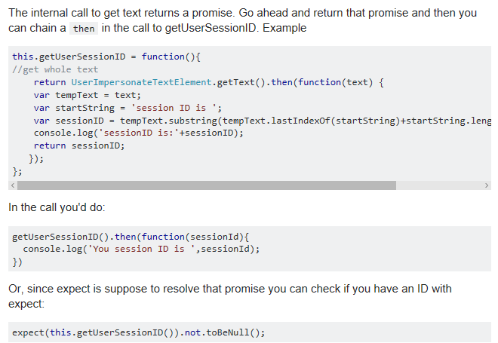

**Scenario 1:**

**let** total =  psearchPlans.**_TBL**.**element**(**by**.**tagName**(**'tbody'**)).all(**by**.**tagName**(**'tr'**)).then(**function** (rows) {  
    **return** rows.length;  
});  
fcommon_obj.__log(total); *// does not work*expect(total).toBe(5); *// this works as it is inside a promise*

**Scenario 2:**

**let** tblRows = {}; // global parameter in this script

psearchPlans.**_TBL**.**element**(**by**.**tagName**(**'tbody'**)).all(**by**.**tagName**(**'tr'**)).then(**function** (rows) {  
    tblRows = rows.length;  
});  
  
***console***.log(**'used here:'** + tblRows); *// NOT work inside same "it" block***for**(**let** i=0;i<tblRows;i++)  *// NOT work inside same "it" block* psearchPlans.__TBL_ReturnPlanName(i).then(**function**(txt){  
        fcommon_obj.__log(tblRows);  
        fcommon_obj.__log(txt);  
        **if**(txt===td.**Plan**)  
            psearchPlans.__TBL_SelectByIndex(i);  
    });

**Scenario 3:**

**let** tblRows = {};  
  
**it**(**'get value'**, **function** () {  
    psearchPlans.**_TBL**.**element**(**by**.**tagName**(**'tbody'**)).all(**by**.**tagName**(**'tr'**)).then(**function** (rows) {  
        tblRows = rows.length;  
    });  
});  
  
  
**it**(**'use value'**, **function** () {  
    ***console***.log(**'used here:'** + tblRows); *// works because it in another "it" block* ***console***.log(**'plain text'**); *// print the text at proper time, not at the very beginig* **for**(**let** i=0;i<tblRows;i++) *// works because it in another "it" block* psearchPlans.__TBL_ReturnPlanName(i).then(**function**(txt){  
            fcommon_obj.__log(tblRows);  
            fcommon_obj.__log(txt);  
            **if**(txt===td.**Plan**)  
                psearchPlans.__TBL_SelectByIndex(i);  
        });  
});

**recursive**

// sample： fcommon_test.__runTillComplete(pcommon_page.**_Icon_Complete**, 10, 1);

**this**.__runTillComplete = **function** (el, totalCount, currentCount) {  
 **let** self = **this**;  
 *// fcommon_obj.__log('currentCount: ' + currentCount);  
 // let _element = element(by.css('[class="mul-icon-checkmark"]'));* **if** (currentCount < totalCount) {  
 **return** el.isPresent().then(**function** (present) {  
 **if** (!present) {  
 fcommon_obj.__log(**'loop in process: '** + currentCount);  
  
 *//// steps inside the loop - start* **browser**.**driver**.navigate().refresh();  
 pcommon_page.__wait4Loading(**null**, **true**);  
 **browser**.sleep(2000);  
 *//// steps inside the loop - end* self.__runTillComplete(el, totalCount, currentCount+1);  
 }  
 **else**{  
 fcommon_obj.__log(**'loop completed:'** + currentCount);  
 }  
 })  
 }  
 **else** {  
 fcommon_obj.__log(**'loop reach to max: '** + totalCount);  
 **throw new** Error(**'Function __runTillComplete failed because condition NOT meet in time'**);  
 **return false**; *//if element not present after Max count reached.* }  
}

**Using Filter**

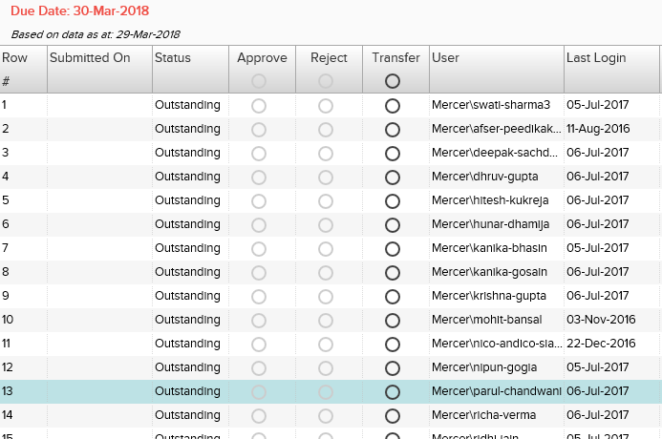

*/////// 13 is displayed and clickable*passignments.**_ApporvalGrid**.all(**by**.**css**(**'[col-id=rownum]'**)).filter(**function**(el, index){  
 **return** el.getText().then(**function**(txt){  
 **return** txt===**'13'**;  
 });  
}).first().isDisplayed().then(**function**(displayed){  
 fcommon_obj.__log(displayed);  
});  
  
passignments.**_ApporvalGrid**.all(**by**.**css**(**'[col-id=rownum]'**)).filter(**function**(el, index){  
 **return** el.getText().then(**function**(txt){  
 **return** txt===**'13'**;  
 });  
}).first().click();

*/////// 33 is NOT displayed and can be automatically scroll into view and clickable*passignments.**_ApporvalGrid**.all(**by**.**css**(**'[col-id=rownum]'**)).filter(**function**(el, index){  
 **return** el.getText().then(**function**(txt){  
 **return** txt===**'33'**;  
 });  
}).first().isDisplayed().then(**function**(displayed){  
 fcommon_obj.__log(displayed);  
});  
  
passignments.**_ApporvalGrid**.all(**by**.**css**(**'[col-id=rownum]'**)).filter(**function**(el, index){  
 **return** el.getText().then(**function**(txt){  
 **return** txt===**'33'**;  
 });  
}).first().click();

*//////// 83 is not exist, so report error in   
///////◦Failed: Index out of bound. Trying to access element at index: 0, but there are only 0 elements that match locator By(css selector, [col-id=rownum]) [stack]*passignments.**_ApporvalGrid**.all(**by**.**css**(**'[col-id=rownum]'**)).filter(**function**(el, index){  
 **return** el.getText().then(**function**(txt){  
 **return** txt===**'83'**;  
 });  
}).first().click();

**Return list of attributes using loop:**

Function as below:

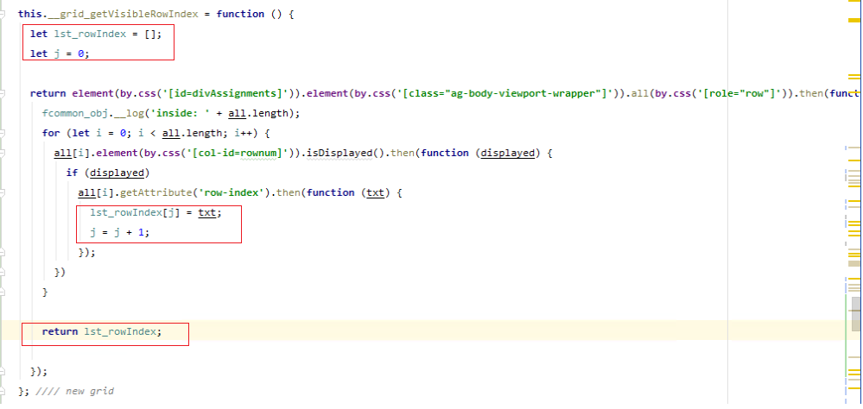

Function call in script:

passignments.__grid_getVisibleRowIndex().then(**function**(lst_rowIndex){  
 fcommon_obj.__log(lst_rowIndex.length);  
 fcommon_obj.__log(lst_rowIndex);  
});